EE6310

Problem Set 15

In this problem set, you will work on your homework in a python notebook.

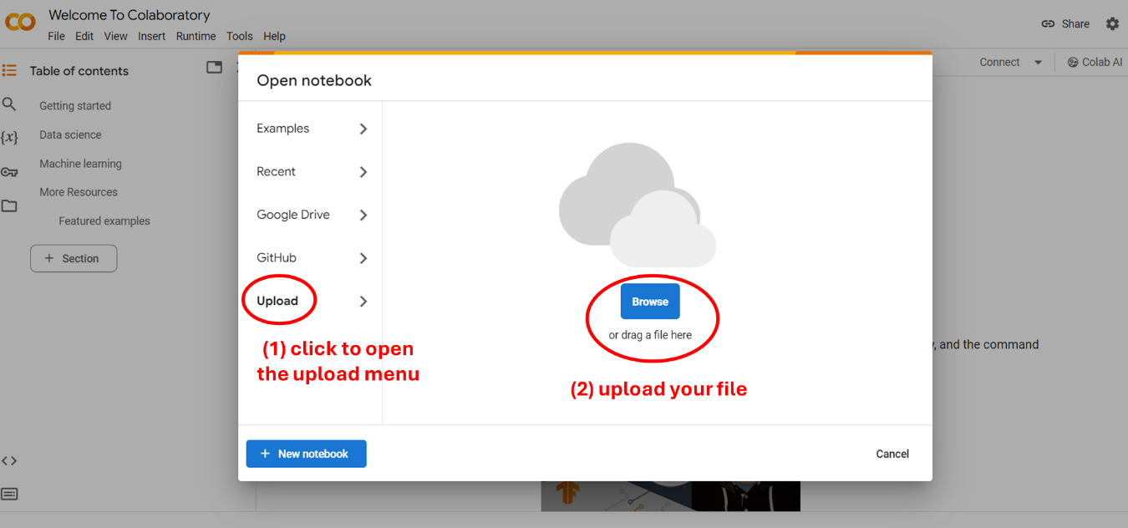

Upload "HW15.ipynb" to the Google Colab via the instruction above and follow the steps to answer questions.